REASON

Standardized Regression Weights: (Group number 1 - Default model)
 |  |  | Estimate
R19 | <--- | Reason | .763
R24 | <--- | Reason | .744
R39 | <--- | Reason | .711
R42 | <--- | Reason | .780
R21 | <--- | Reason | .756
R31 | <--- | Reason | .759
R20 | <--- | Reason | .782
R29 | <--- | Reason | .703
R34 | <--- | Reason | .769
R35 | <--- | Reason | .741
R26 | <--- | Reason | .773
R33 | <--- | Reason | .746
R27 | <--- | Reason | .739
R43 | <--- | Reason | .760
R23 | <--- | Reason | .740
R41 | <--- | Reason | .777
R32 | <--- | Reason | .746
R40 | <--- | Reason | .724
R28 | <--- | Reason | .710
R22 | <--- | Reason | .736
R25 | <--- | Reason | .790
R38 | <--- | Reason | .724
R30 | <--- | Reason | .711
R36 | <--- | Reason | .752
R37 | <--- | Reason | .741
R44 | <--- | Reason | .666

Reliability

Scale: ALL VARIABLES

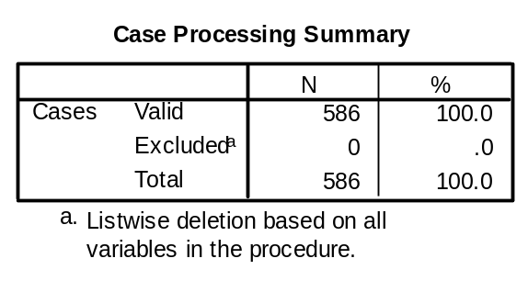

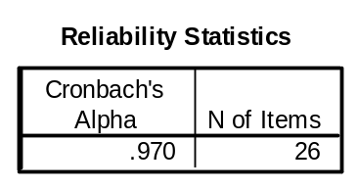

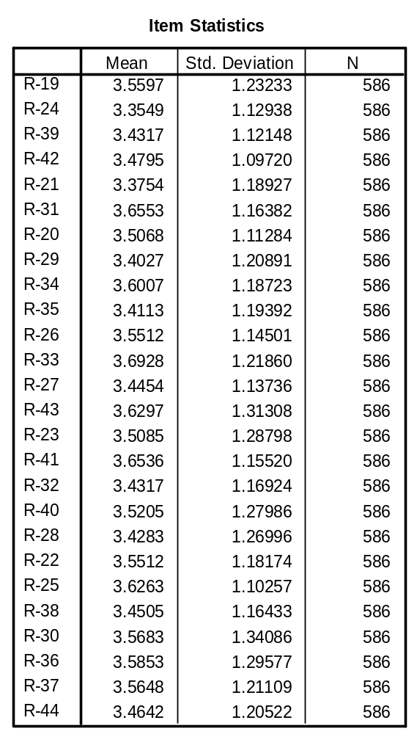

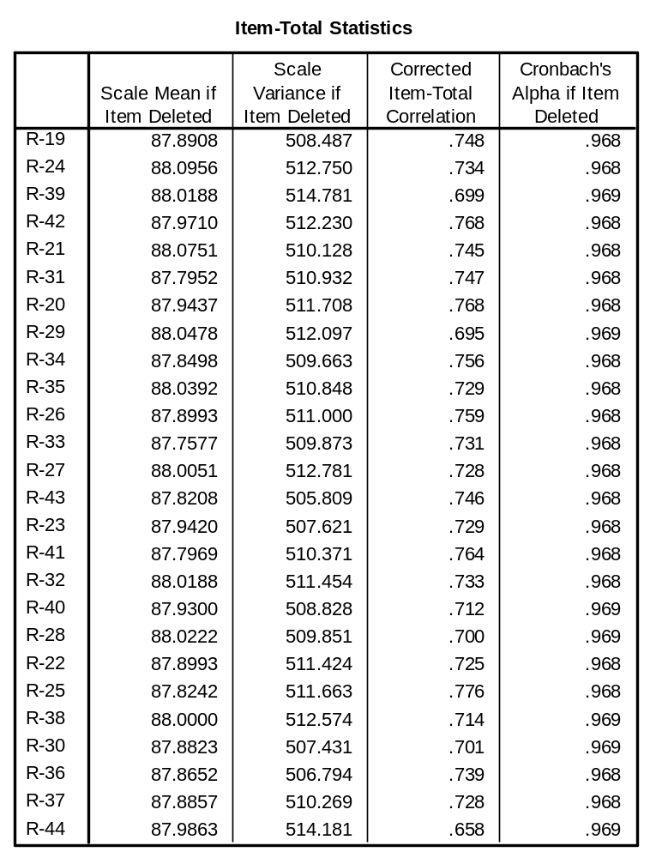

REASONS
No | Mean | SD | Loading Factor | Cronbach's Alpha | CR | AVE
R-19 | 3.56 | 1.23233 | 0.763 | 0.97 | 0.970 | 0.554
R-24 | 3.355 | 1.12938 | 0.744
R-39 | 3.432 | 1.12148 | 0.711
R-42 | 3.48 | 1.0972 | 0.78
R-21 | 3.375 | 1.18927 | 0.756
R-31 | 3.655 | 1.16382 | 0.759
R-20 | 3.507 | 1.11284 | 0.782
R-29 | 3.403 | 1.20891 | 0.703
R-34 | 3.601 | 1.18723 | 0.769
R-35 | 3.411 | 1.19392 | 0.741
R-26 | 3.551 | 1.14501 | 0.773
R-33 | 3.693 | 1.2186 | 0.746
R-27 | 3.445 | 1.13736 | 0.739
R-43 | 3.63 | 1.31308 | 0.76
R-23 | 3.509 | 1.28798 | 0.74
R-41 | 3.654 | 1.1552 | 0.777
R-32 | 3.432 | 1.16924 | 0.746
R-40 | 3.521 | 1.27986 | 0.724
R-28 | 3.428 | 1.26996 | 0.71
R-22 | 3.551 | 1.18174 | 0.736
R-25 | 3.626 | 1.10257 | 0.79
R-38 | 3.451 | 1.16433 | 0.724
R-30 | 3.568 | 1.34086 | 0.711
R-36 | 3.585 | 1.29577 | 0.752
R-37 | 3.565 | 1.21109 | 0.741
R-44 | 3.464 | 1.20522 | 0.666

AREAS

Standardized Regression Weights: (Group number 1 - Default model)
 |  |  | Estimate
A1 | <--- | Area | .666
A2 | <--- | Area | .719
A3 | <--- | Area | .621
A4 | <--- | Area | .700
A5 | <--- | Area | .743
A6 | <--- | Area | .782
A7 | <--- | Area | .727
A8 | <--- | Area | .657
A9 | <--- | Area | .769
A10 | <--- | Area | .745
A11 | <--- | Area | .721
A12 | <--- | Area | .727
A13 | <--- | Area | .687
A14 | <--- | Area | .735
A15 | <--- | Area | .677
A16 | <--- | Area | .740
A17 | <--- | Area | .701
A18 | <--- | Area | .743

Reliability

Scale: ALL VARIABLES

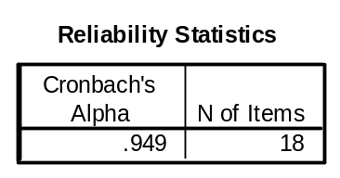

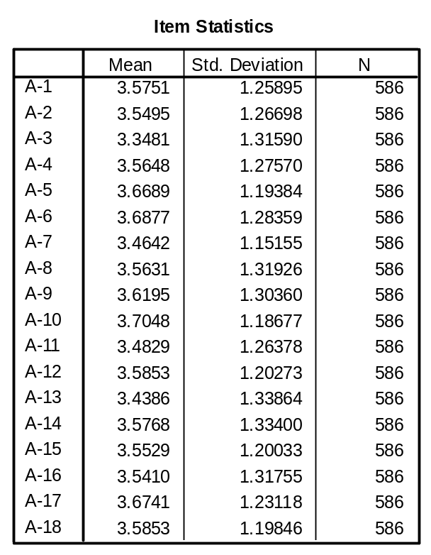

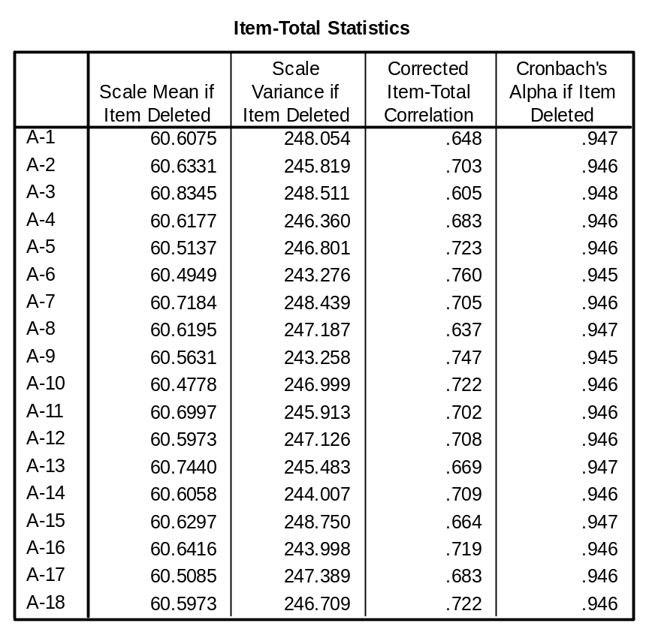

AREA
No | Mean | SD | Loading Factor | Cronbach's Alpha | CR | AVE
A1 | 3.575 | 1.25895 | 0.666 | 0.949 | 0.950 | 0.512
A2 | 3.55 | 1.26698 | 0.719
A3 | 3.348 | 1.3159 | 0.621
A4 | 3.565 | 1.2757 | 0.7
A5 | 3.669 | 1.19384 | 0.743
A6 | 3.688 | 1.28359 | 0.782
A7 | 3.464 | 1.15155 | 0.727
A8 | 3.563 | 1.31926 | 0.657
A9 | 3.62 | 1.3036 | 0.769
A10 | 3.705 | 1.18677 | 0.745
A11 | 3.483 | 1.26378 | 0.721
A12 | 3.585 | 1.20273 | 0.727
A13 | 3.439 | 1.33864 | 0.687
A14 | 3.577 | 1.334 | 0.735
A15 | 3.553 | 1.20033 | 0.677
A16 | 3.541 | 1.31755 | 0.74
A17 | 3.674 | 1.23118 | 0.701
A18 | 3.585 | 1.19846 | 0.743

